University Name: San Jose State University

Course: CMPE 281

Student: Tingjia Zhang

Student ID: 015242708

Professor: Sanjay Garje

Project introduction: DirectIndustry Web Guide

Project Idea: DirectIndustry Web Guide

People search information they need on browsers. For a part of the users, they will use default browser (Safari or IE) and do no changes for their browser. For some people, they may do some changes to the browsers based on their customs. For example, using setting buttons to change the skins of the browsers, adding some plug-in functions. However, the function of the setting buttons cannot meet the needs of all users. For some people, an online DirectIndustry Web Guide is a much better choice.

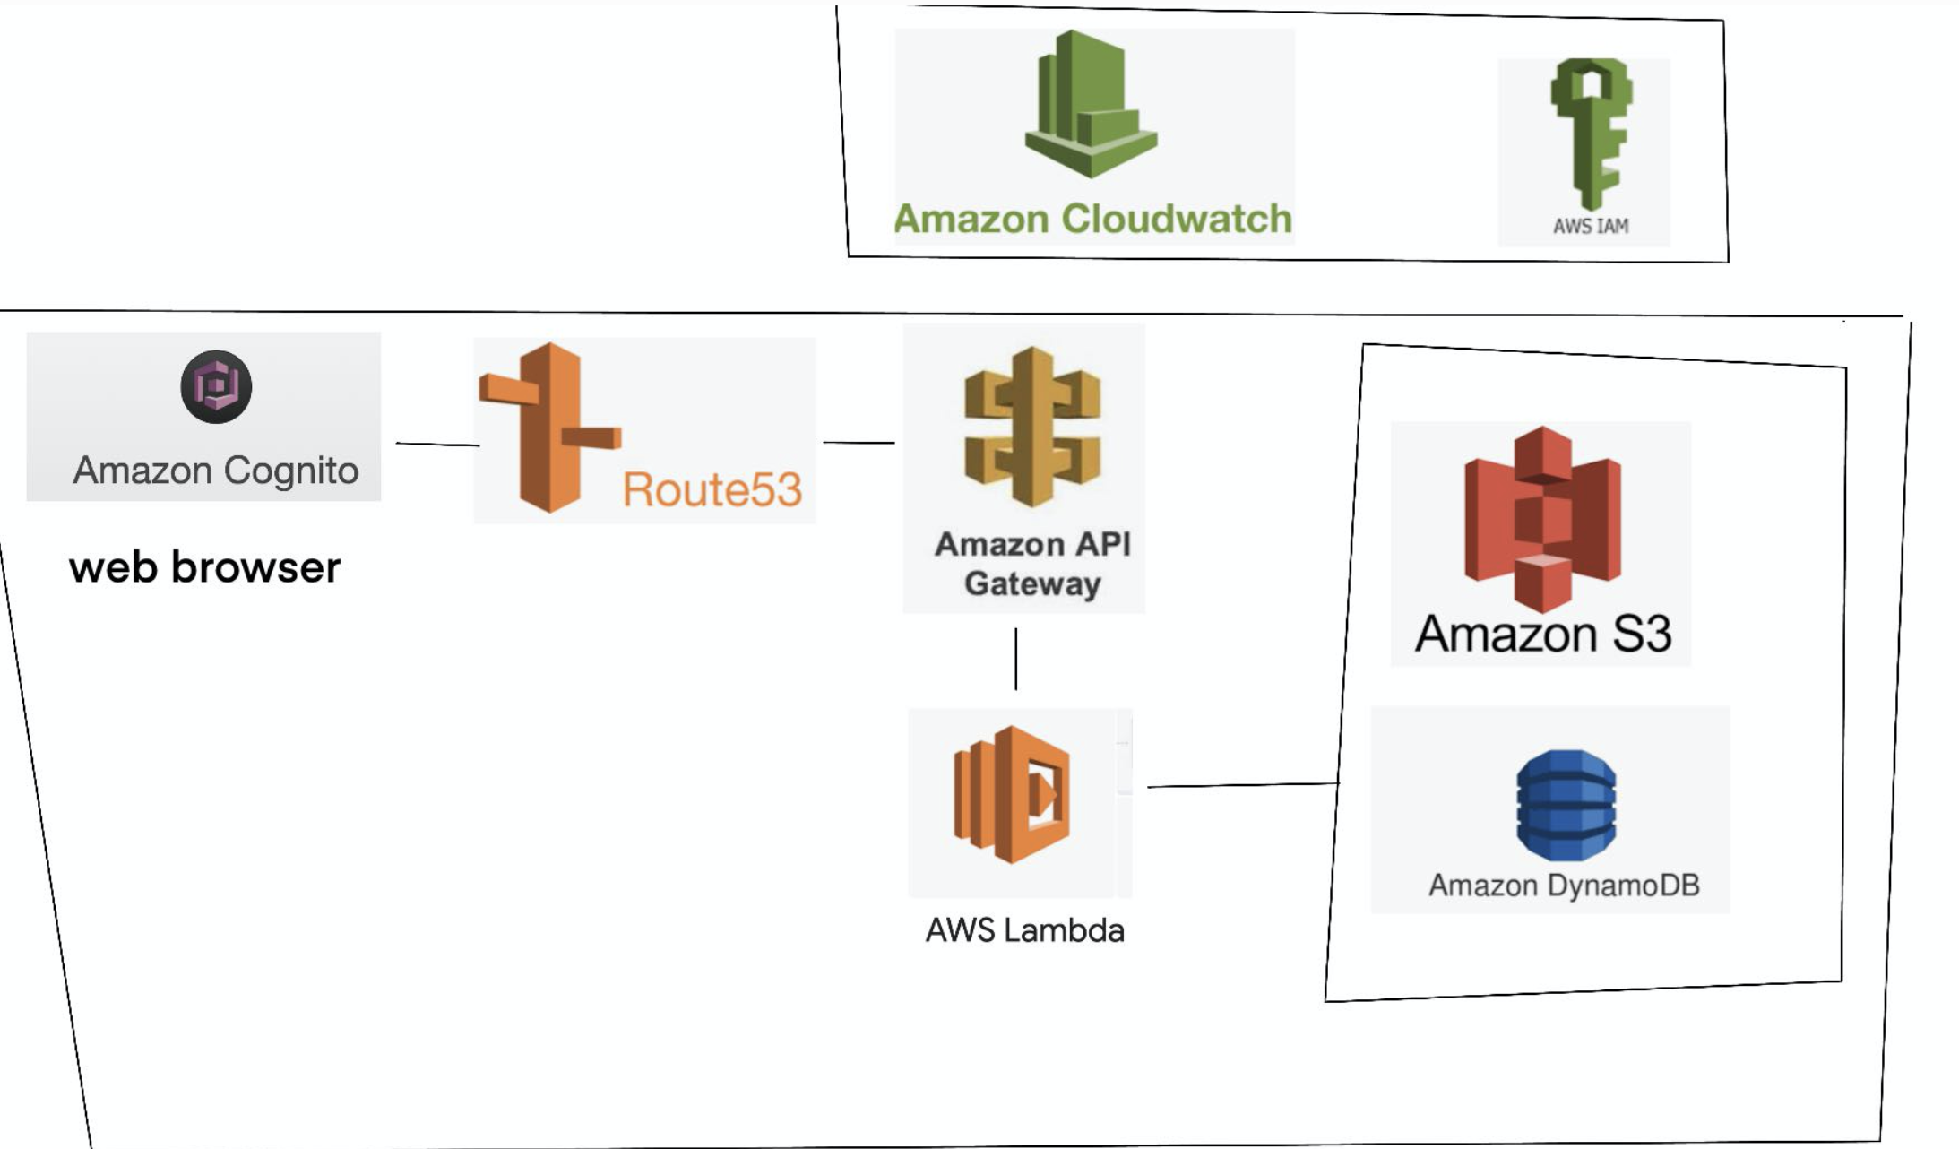

In this project, I design a serverless website application based on AWS to solve the problems.

After going through a few simple registration steps, the users can use either an online DirectIndustry Web Guide or an offline mode with local files. This project is a combination of many AWS services which involve S3 buckets, DynamoDB, API Gateway, Lambda, IAM, Cognito, etc.

Link: <http://assignment4.com.s3-website.us-east-2.amazonaws.com/>

Screen Shot:

1. Home page: 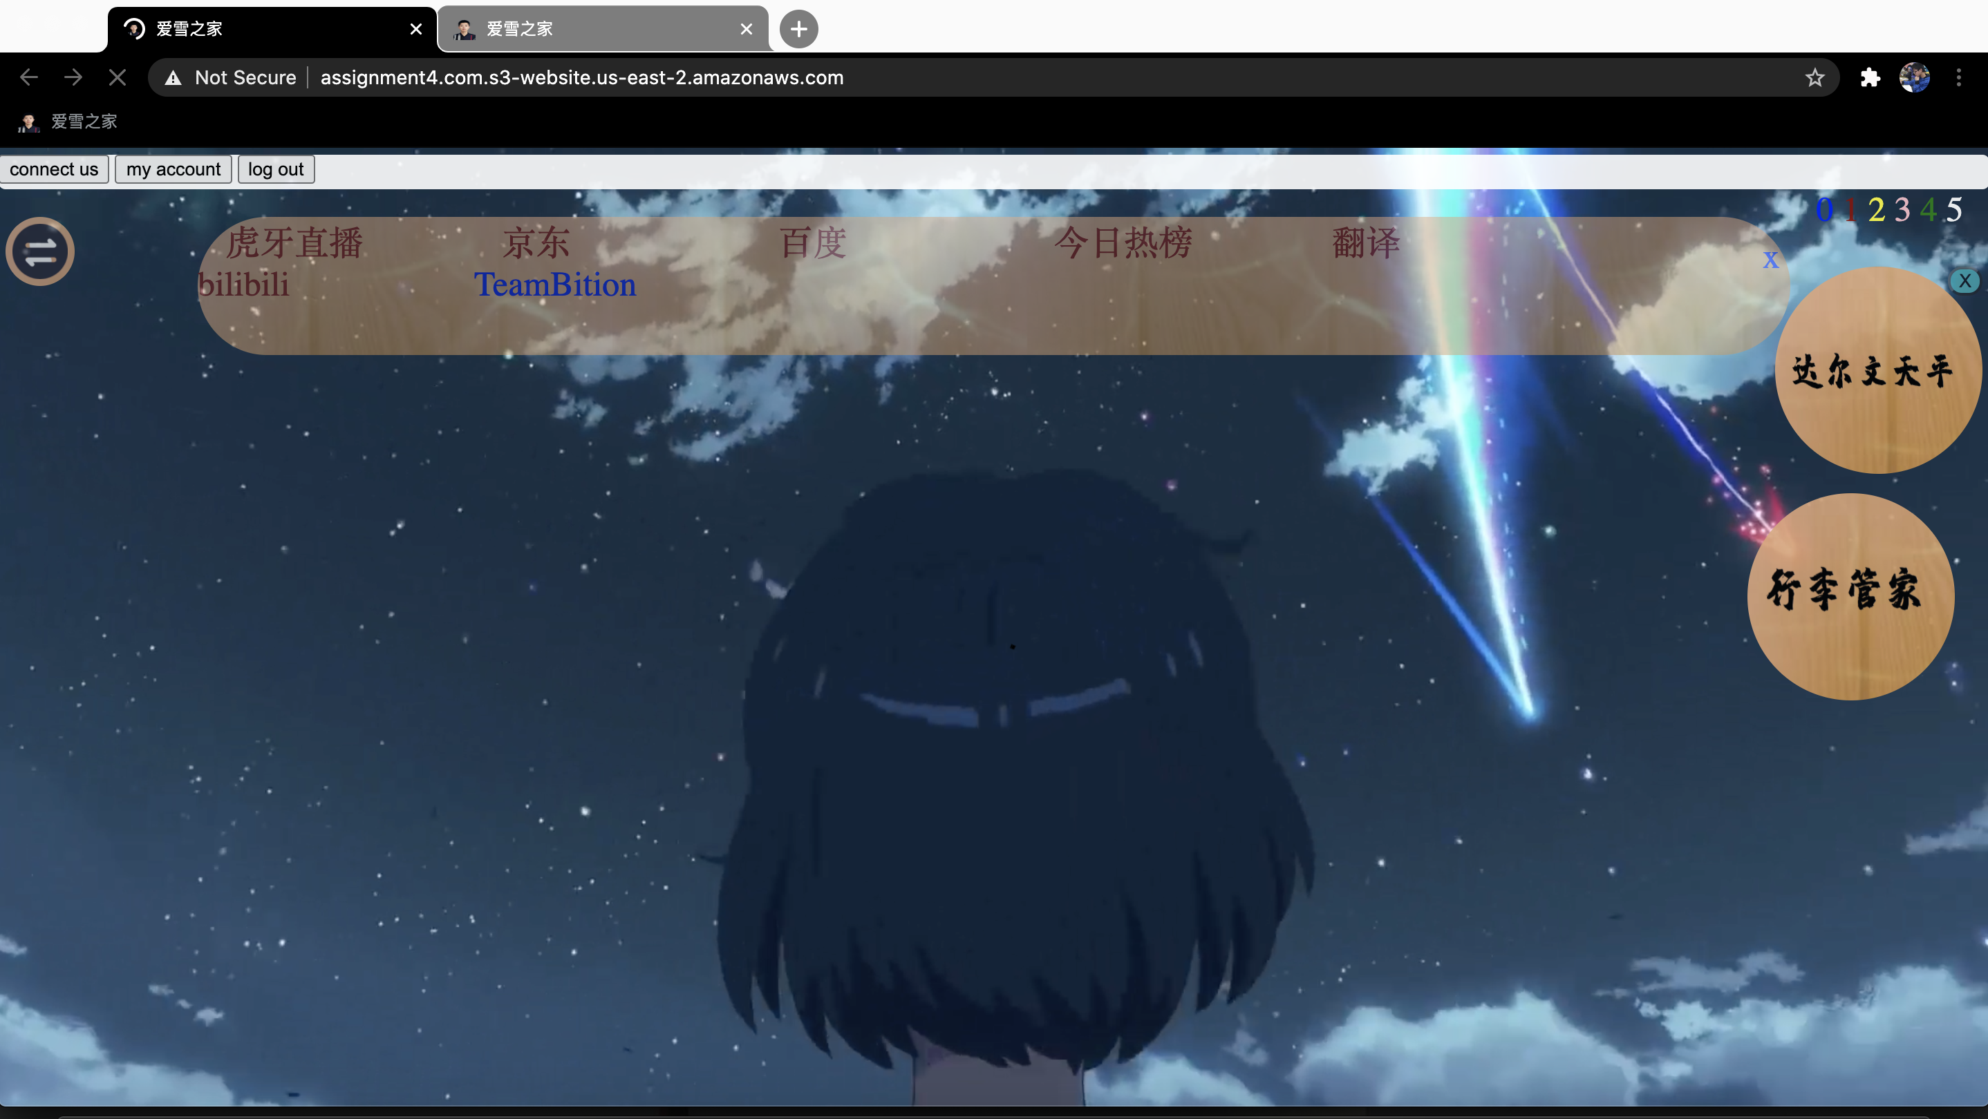
2. Sign in :



1. Registration:

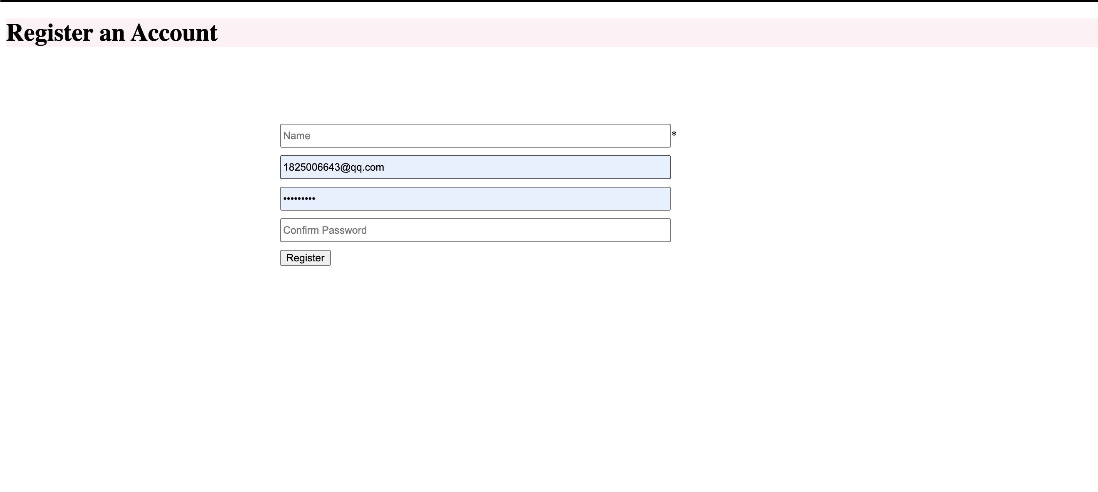

1. Main function

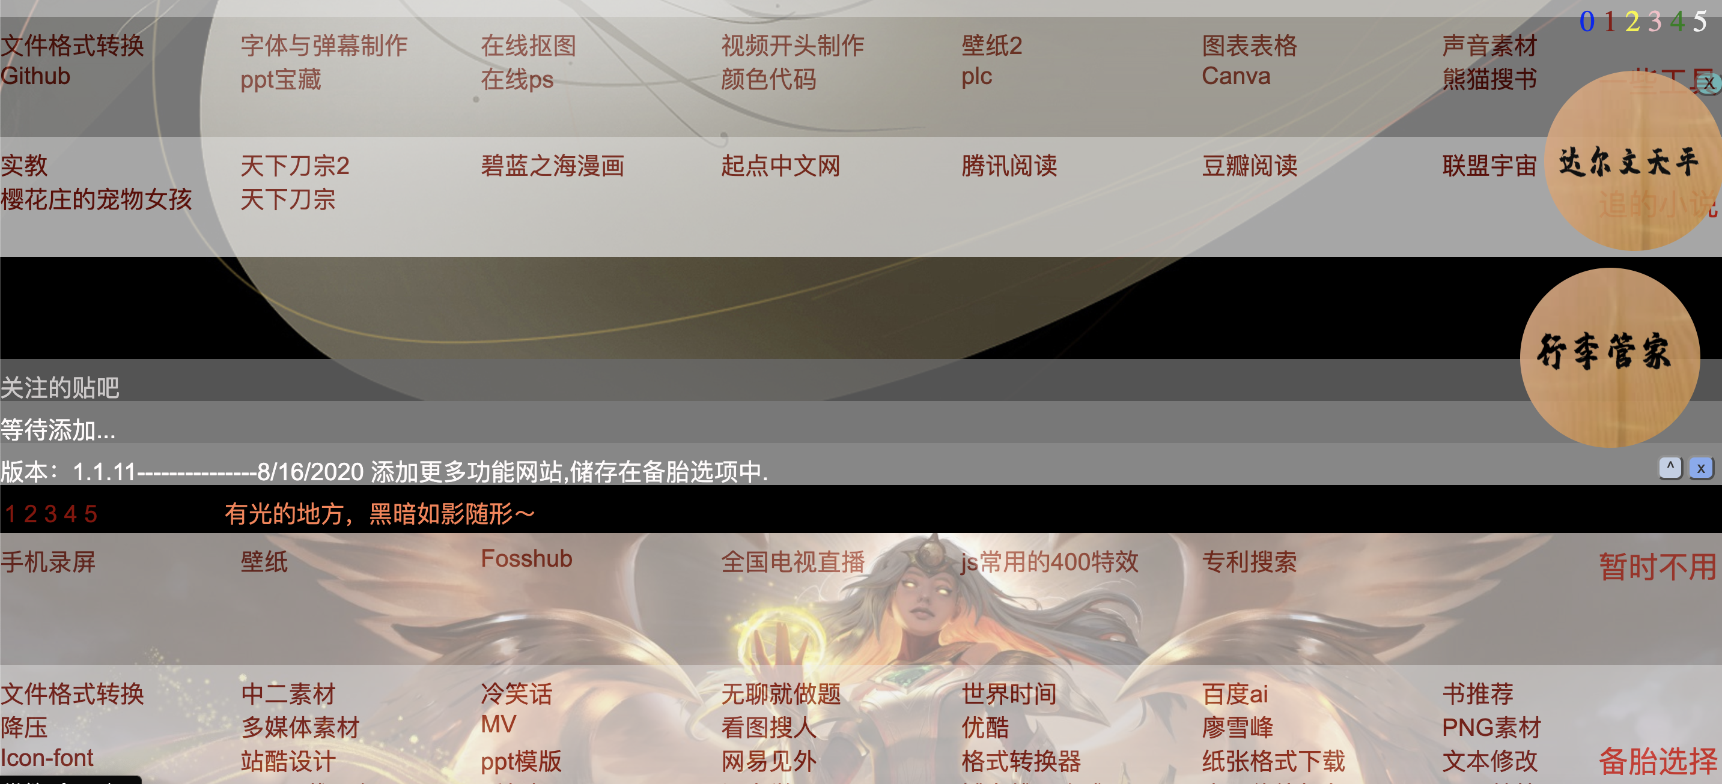

1. Feedback:

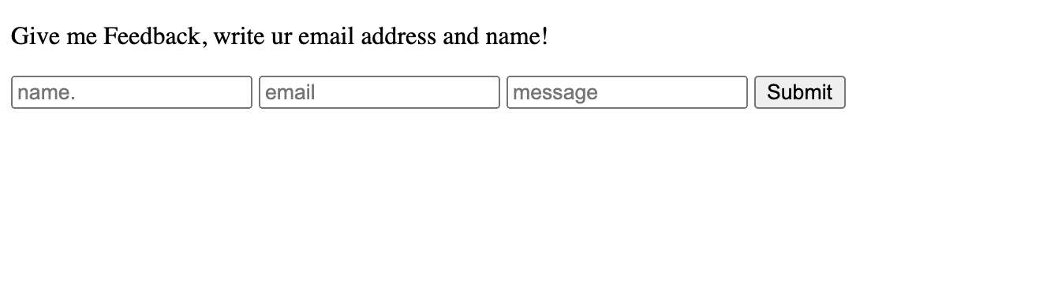

1. Additional tool function:

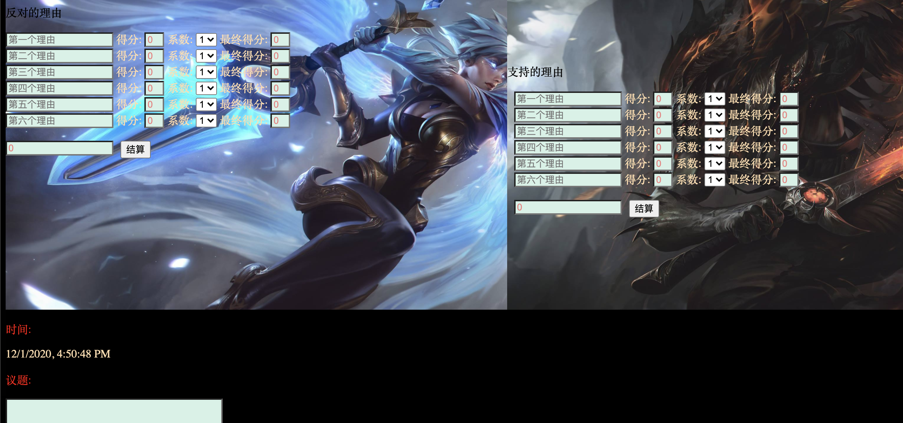

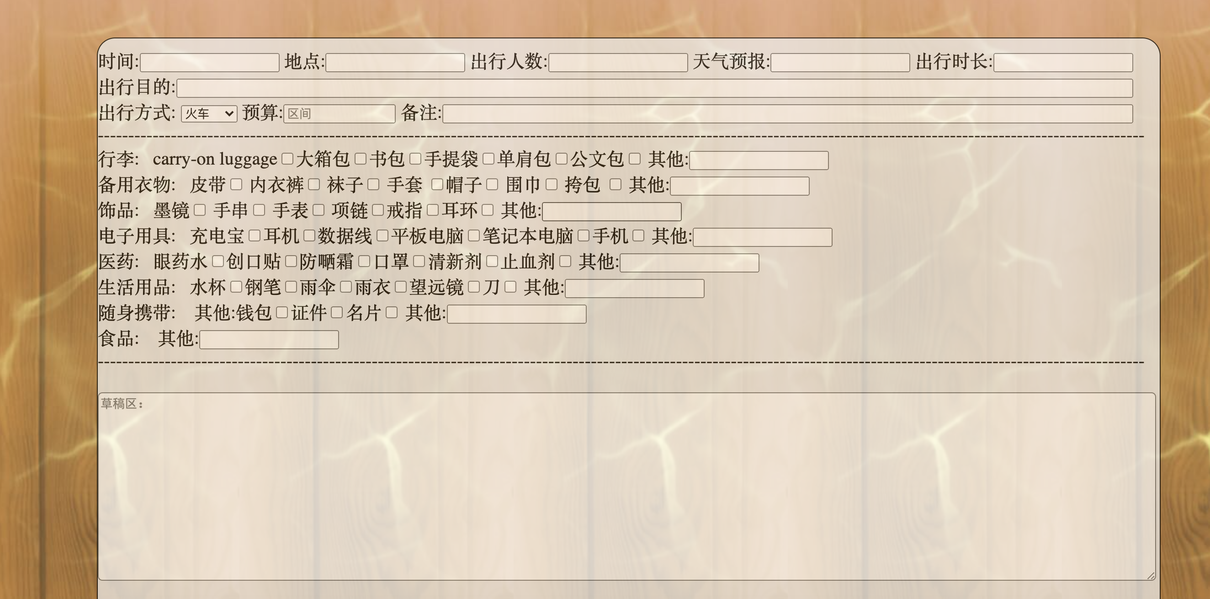

1. Music bar



1. Lock screen

